# GRE over IPSec

1. Install RAS with default options

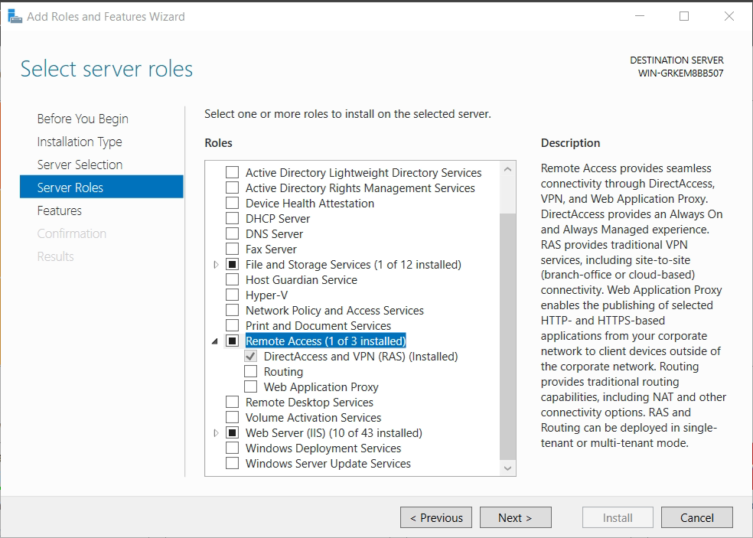

1. Configure it with “Deploy VPN only”
2. Enable Routing and Remote Access with custom configuration

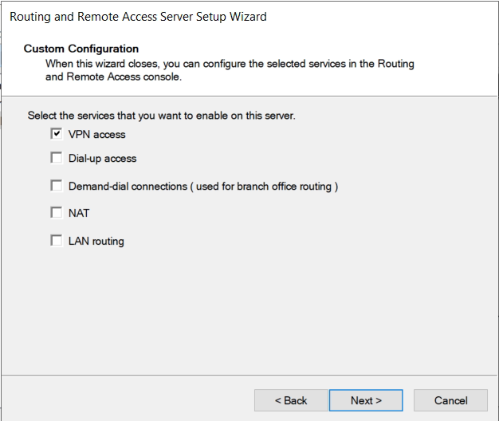

1. PS> Add-VpnS2SInterface -Name GRE -GreTunnel -SourceIpAddress <local_physical_ip> -Destination <remote_physical_ip> -IPv4Subnet <gre_subnet>/<gre_subnet_mask>:<metric> -IPv4Address <local_ip_in_gre_subnet>
2. New Demand-dial Interface  
   VPN type: IKEv2  
   Destination IP is in the GRE network  
   Protocols and Security are on default.  
   Add static route to the remote subnet  
   Dial-Out credentials are left on blank.

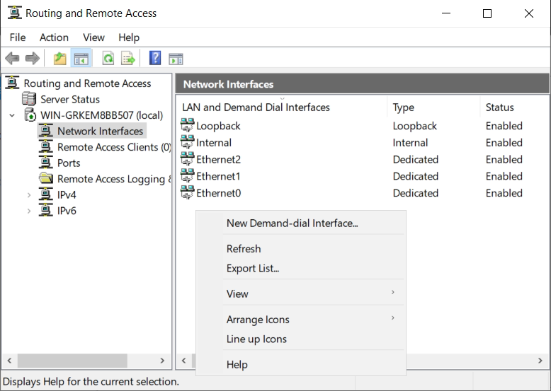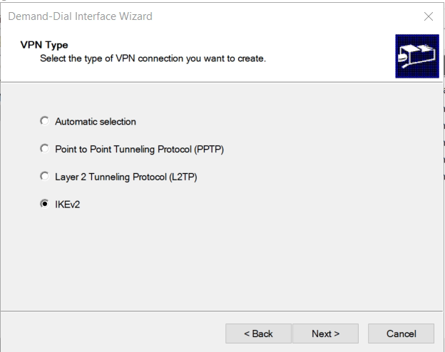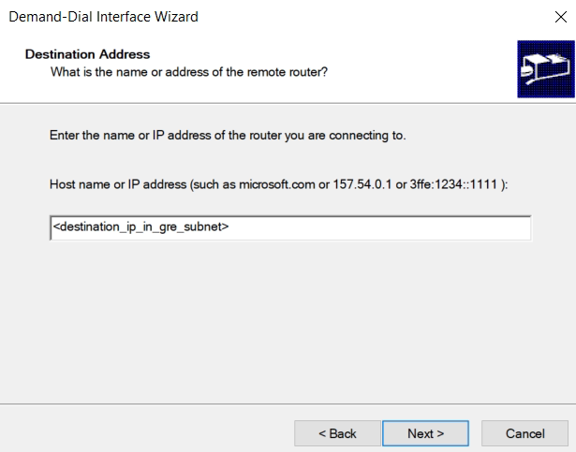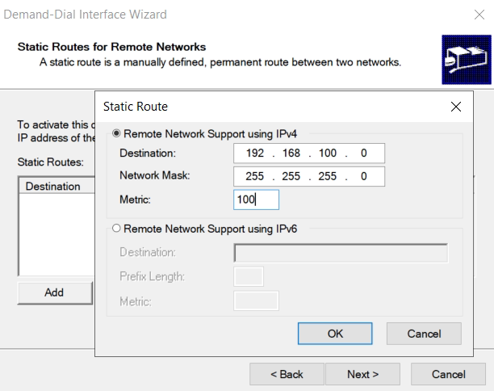

1. Right Click -> Properties -> Security

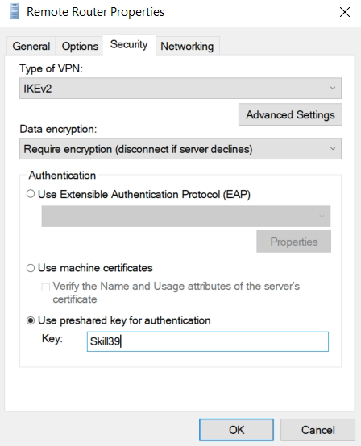

1. Right Click -> Connect

Frequent problems:

This object already exists: Not a real problem. Wait a few seconds, and retry.

Unreachable: Check if the GRE tunnel is Connected, using “Get-VpnS2SInterface -Name GRE” in PowerShell.

Other types of errors are better reported on the Linux Syslog.